Web-Based Document Automation Management System

*Felicisimo, Melvin G.*

*Aster, Kyle Chadwick V.*

*Rosel, Bryan Russel I.*

**Data Mapping**

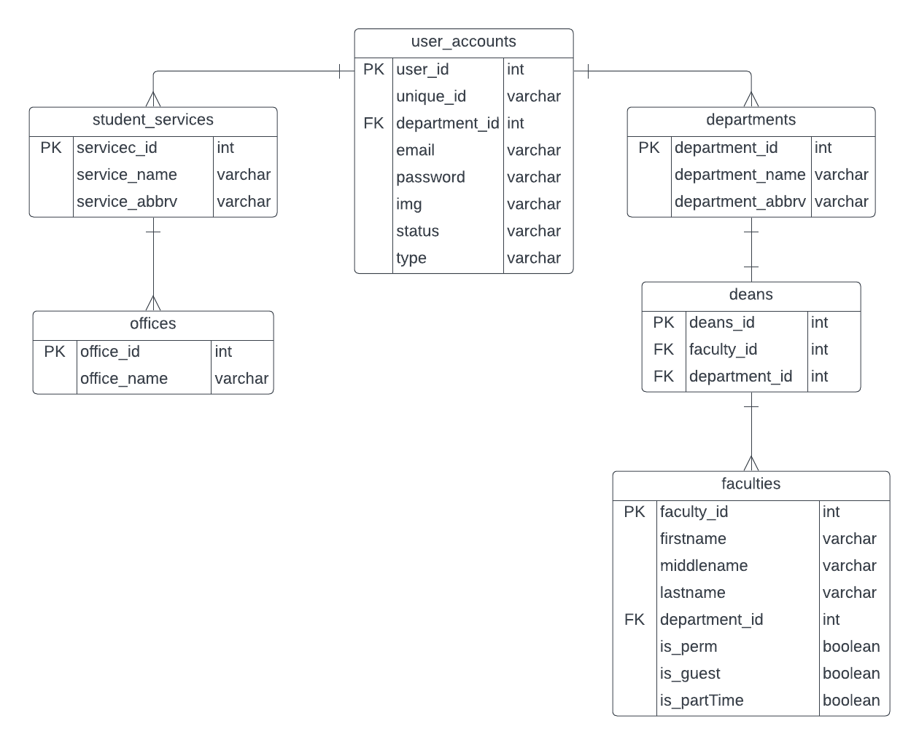

*User Account Validation:*

In this process, the type of user will be validated by the system to identify its user and direct them to their corresponding user interface.

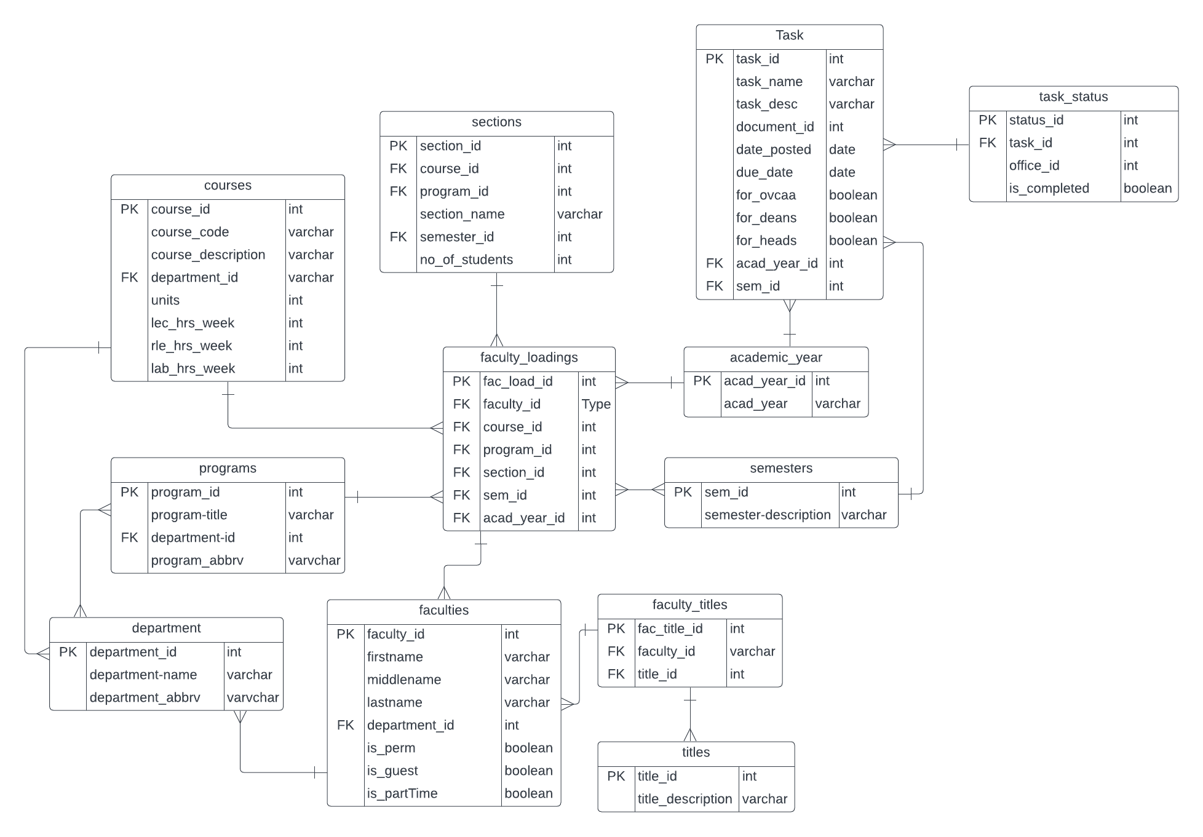

*Assignment of Task:*

In this process, the creator of the task will fill out the form with the details of the task, including the start date, deadline, title, description, and where it will be assigned. The task will be directed to its corresponding user or receiver for completion and passing after it's finished.

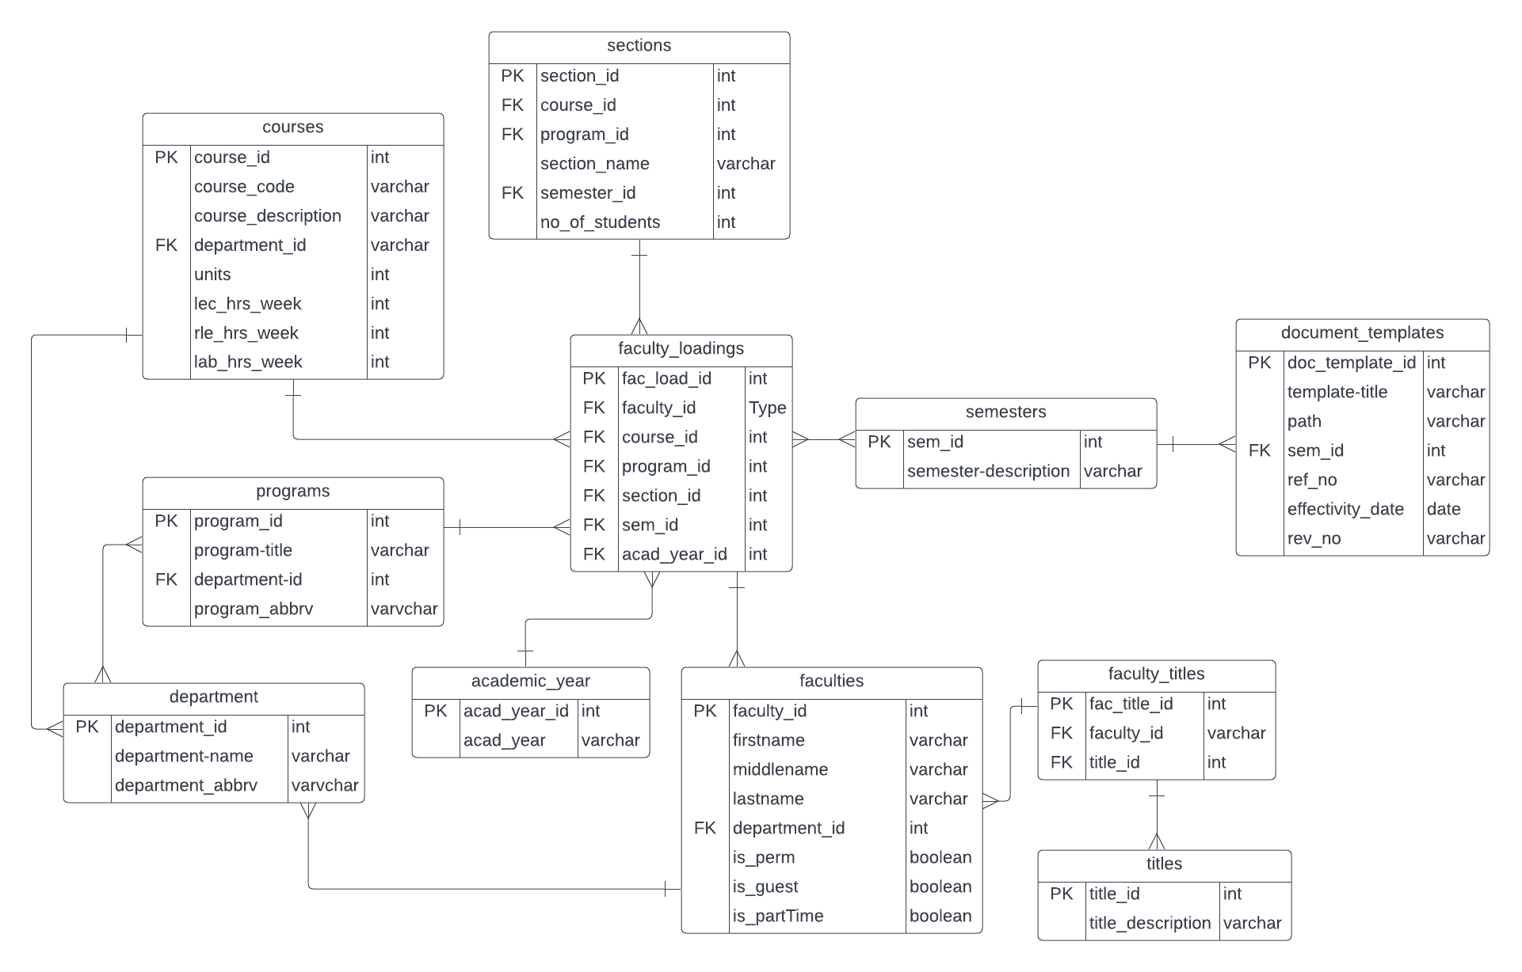

*Importing Data in Documents:*

This process will include eleven tables, namely courses, sections, programs, semesters, departments, academic_year, faculty_loadings, faculties, faculty_titles, titles, and document_templates. The editor of the document will import the other information into the document.